**Emission Spectrum (Spectrum Tubes)**

The ***emission spectrum*** is the set of light frequencies emitted by substances after they have been excited with various forms of energy, most commonly heat or electrical. Since the frequency of light emitted under these conditions depends on the energies of the excited and ground states of electrons in the atoms, the spectrum serves as a very sensitive “fingerprint” of the atoms present. For example, by studying emission spectra of the stars, we can determine their chemical composition. Comparisons to the visible spectrum allows for an estimation of the energy required to excite an electron for a particular gas.

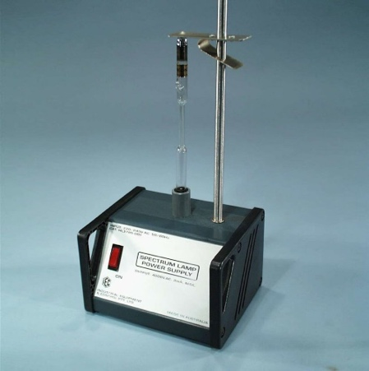

**Aims**

To observe emission spectra of electrically excited gases.

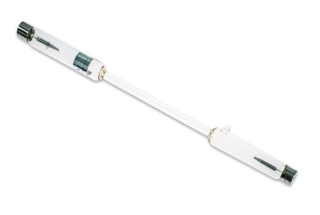

**Apparatus/Equipment**

* Spectrum lamp power box
* Various spectrum tubes

**Risk Assessment**

|  |  |
| --- | --- |
| What are the risks in doing this experiment? | How can you manage these risks to stay safe? |
| The spectrum tubes will get hot and may cause burns. | Turn the spectrum lamp off and allow the tubes to cool before removing. |
| Spectrum tubes are fragile and contain glass. They may break causing cuts. | Be careful when handling the glass tubes. |

**Procedure/Method**

1. Ensure the spectrum tube power supply is turned off before plugging it into the socket.

**NOTE:**

Spectrum tubes should not be on for more than 30 seconds, and should be rested for 30 seconds between being excited.

1. Place a spectrum tube into the spectrum tube power supply.
2. Turn off lights to darken room.
3. Turn the spectrum tube power supply on, and view the light through diffraction glasses, recording the colours emitted.
4. Turn the power supply off, repeating steps 4 & 5 with other tubes.

NOTE:

1. 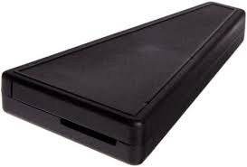Look through a ***diffraction grating spectroscope*** at daylight or a regular tungsten light bulb. All of these sources give "continuous" rather than "discrete line" spectra; that is, they give the whole rainbow of colours, each merging into the next.
2. Darken the area and use the diffraction grating to look at the displayed elements in gas discharge tubes.  Record the spectrum produced by each. Use crayons or coloured pencils to record the colours seen by making vertical lines on the space below to represent the spectra obtained.

EISCO High Resolution Quantitative Spectroscope, 400-700 nm

**Results**

1. Draw a table of the gas observed in the spectrum tubes and the coloured emitted.
2. Record your results in the table, using either words or photos.

|  |  |  |
| --- | --- | --- |
| **Gas** | **Colour Emitted** | **Wavelengths of spectrum spikes**  **(possible multiple wavelengths)**  **(400-700 nm)** |
| Hydrogen (H) |  |  |
| Helium (He) |  |  |
| Neon (Ne) |  |  |
| Argon (Ar) |  |  |
| Krypton (Kr) |  |  |
| Xenon (Xn) |  |  |
| Mercury Vapor (Hg) |  |  |
| Oxygen (O) |  |  |
| Water Vapor (H2O) |  |  |

**Analysis**

1. What causes light to be emitted by an atom?
2. Why are only certain wavelengths emitted from an atom? (In other words, why do the spectra show lines of light instead of a continuous rainbow of light?)